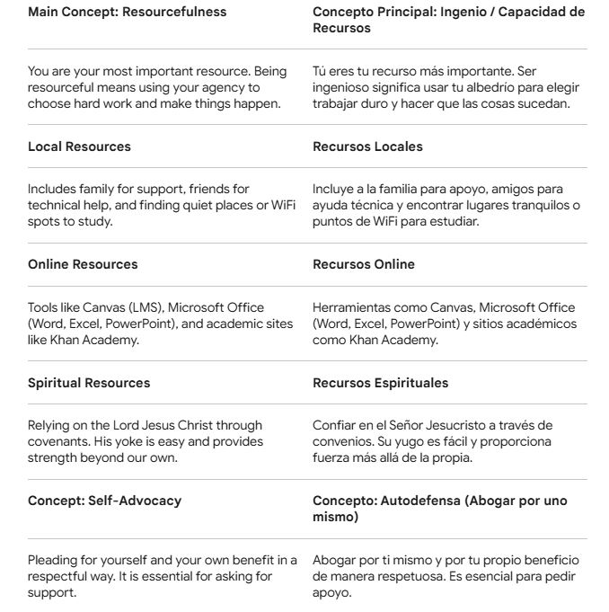
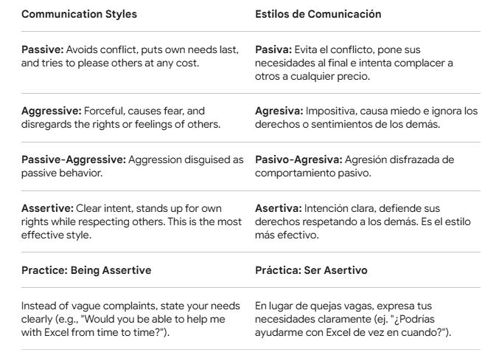
PRAYER
Our Beloved Heavenly Father,
At this hour we draw near unto Thee with humble hearts, recognizing Thy hand in our lives. We thank Thee for the gift of agency and for reminding us that we are our most valuable earthly resource; we thank Thee for digital tools, for our family, and especially for the example of Thy Son, Jesus Christ, whose yoke makes our burdens light.
We ask Thee to grant us Thy Spirit to develop the capacity to be resourceful in the face of our academic challenges. Help us to communicate with assertiveness, clarity, and respect, so that we may advocate for our goals without forgetting the needs of others. Strengthen us to be self-reliant, but also humble enough to seek support within our network of local and spiritual resources.
May that which we have learned in this lesson help us to press forward with faith, knowing that with Thy help we will receive strength beyond our own.
We ask for all these things with gratitude, in the name of our Lord Jesus Christ. Amen.

